Infosys Springboard Internship Program

REPORT

EnviroScan: AI-Based Pollution Source Identification System using Geospatial Analytics

TABLE OF CONTENTS PAGE NUMBER
1. Abstract 2
2. Introduction 2
3. Problem Statement 2-3
4. Module Description 3-4
5. Tech Stack 5
6. Methodology 5-6
7. Results 6-8
8. Solution 9
9. Conclusion 9

- ABSTRACT
EnviroScan is an AI-based system designed to identify pollution sources using environmental data and geospatial analysis. Traditional pollution monitoring systems focus only on measuring pollutant levels without identifying their origin. This project addresses that limitation by combining machine learning techniques with real-world environmental data.
The system collects air quality, weather, and location data, processes it, and classifies pollution sources such as vehicular, industrial, agricultural, and natural causes. Machine learning models like Random Forest are used to improve prediction accuracy. The results are visualized using interactive dashboards and maps, making it easier to understand pollution patterns.
Overall, EnviroScan provides a more meaningful approach to pollution analysis by not only measuring pollution but also explaining its cause and impact.

- INTRODUCTION
Air pollution has become a major concern due to increasing urbanization and industrial activities. Monitoring systems are widely used to track pollution levels; however, they only provide numerical values without identifying the underlying cause.
Understanding the source of pollution is essential for effective control and prevention. Without this information, it becomes difficult to take targeted actions.
EnviroScan is developed to overcome this limitation by integrating environmental data with machine learning and visualization techniques. The system analyzes pollutant levels along with weather and location data to predict the most likely source of pollution.
By presenting the results through an interactive dashboard and geospatial maps, the system helps users gain better insights into pollution trends and patterns.

- PROBLEM STATEMENT
Existing pollution monitoring systems are limited in functionality as they only display pollutant values and fail to provide insights into their origin. This creates a gap between data collection and decision-making.
The lack of source identification leads to:
- Ineffective pollution control strategies
- Limited understanding of pollution patterns
- Inability to take preventive measures
This project aims to design a system that can analyze environmental data and accurately classify pollution sources while providing clear and interactive visualizations.

- Module Description
The EnviroScan system is developed in a modular manner, where each module performs a specific task in the overall pipeline. This structured approach makes the system easier to develop, understand, and maintain. Each module processes the output of the previous stage and contributes to building the final intelligent system.

Module 1: Data Collection
This module is responsible for gathering raw environmental data from external sources. It collects air pollution parameters such as PM2.5, PM10, NO₂, CO, SO₂, and O₃ along with weather data including temperature, humidity, and wind speed. It also captures location-based information such as latitude, longitude, and timestamp.
The main objective of this module is to create a base dataset that reflects real-world environmental conditions. The quality and reliability of this data directly affect the performance of the entire system.

Module 2: Data Cleaning and Feature Engineering
The data collected from different sources is often incomplete, inconsistent, or noisy. This module ensures that the dataset is cleaned and structured properly before further processing.
Duplicate entries are removed, missing values are handled, and column formats are standardized. In addition, new features are created to improve the effectiveness of analysis. These include time-based features such as hour, day, and month, as well as a calculated AQI score that provides a combined measure of pollution levels.
This step is crucial because clean and well-structured data leads to more accurate predictions.

Module 3: Source Labeling
Since real-world datasets do not usually contain labeled information about pollution sources, this module generates the target variable using rule-based logic.
Based on observed pollutant patterns, the system assigns a pollution source such as Vehicular, Industrial, Agricultural, Urban Dust, or Natural. For example, high NO₂ and CO values indicate vehicular emissions, while high SO₂ levels suggest industrial activity.
This module transforms raw environmental data into a supervised learning dataset, making it suitable for machine learning models.

Module 4: Model Training and Prediction
In this module, machine learning algorithms are trained to predict pollution sources based on input features. The dataset is split into training and testing sets to evaluate model performance.
Models such as Random Forest and Decision Tree are used, with Random Forest generally providing better accuracy due to its ensemble nature. Hyperparameter tuning techniques like GridSearchCV are applied to improve model performance.
The trained model is then saved and can be used later for real-time predictions in the dashboard.

Module 5: Geospatial Visualization
This module focuses on visualizing pollution data on a map to provide better understanding of spatial patterns.
Using geospatial tools, the system creates heatmaps that highlight areas with high pollution levels. It also places markers on the map to indicate the predicted pollution source at different locations.
This visual representation helps users quickly identify pollution hotspots and understand how pollution varies across regions.

Module 6: Dashboard and User Interface
The final module integrates all components into an interactive dashboard using Streamlit. This serves as the user interface of the system.
The dashboard allows users to:
- Filter data by city
- View key metrics such as average pollution levels
- Analyze trends using graphs
- Receive alerts based on pollution severity
- Predict pollution sources by entering input values
It also provides options to download data and interact with visualizations, making the system user-friendly and practical for real-world use.

- Tech Stack
The project is implemented using the following technologies:
Programming Language
Python is used due to its simplicity and strong support for data analysis and machine learning.
Libraries and Tools
- Pandas – for data handling and preprocessing
- NumPy – for numerical computations
- Scikit-learn – for machine learning models
- Joblib – for saving and loading models
- Streamlit – for building the dashboard
- Plotly – for interactive graphs
- Folium – for geospatial visualization

- Methodology
The system follows a structured pipeline to ensure accurate results.
Step 1: Data Collection
Data is collected from APIs and includes pollution levels, weather conditions, and location details.
Step 2: Data Cleaning
The collected data is processed to remove duplicates, handle missing values, and standardize formats.
Step 3: Feature Engineering
Additional features such as AQI score, time-based attributes, and spatial information are created to improve model performance.
Step 4: Source Labeling
Since real labels are not available, rule-based logic is used to classify pollution sources based on pollutant patterns.
Step 5: Model Training
Machine learning models like Random Forest and Decision Tree are trained using the processed dataset.
Step 6: Visualization
The results are displayed using graphs, charts, and maps to make the data more understandable.
Step 7: Dashboard Integration
A Streamlit dashboard is built to provide an interactive interface for users.

- Results
The system successfully classifies pollution sources with good accuracy. The Random Forest model performs better compared to the Decision Tree due to its ability to handle complex relationships in data.
The dashboard provides:
- Real-time visualization of pollution data
- Clear identification of dominant pollution sources
- Interactive graphs for analysis
- Heatmaps showing pollution concentration
The system demonstrates that combining machine learning with environmental data can provide meaningful insights beyond traditional monitoring systems.

Outputs –
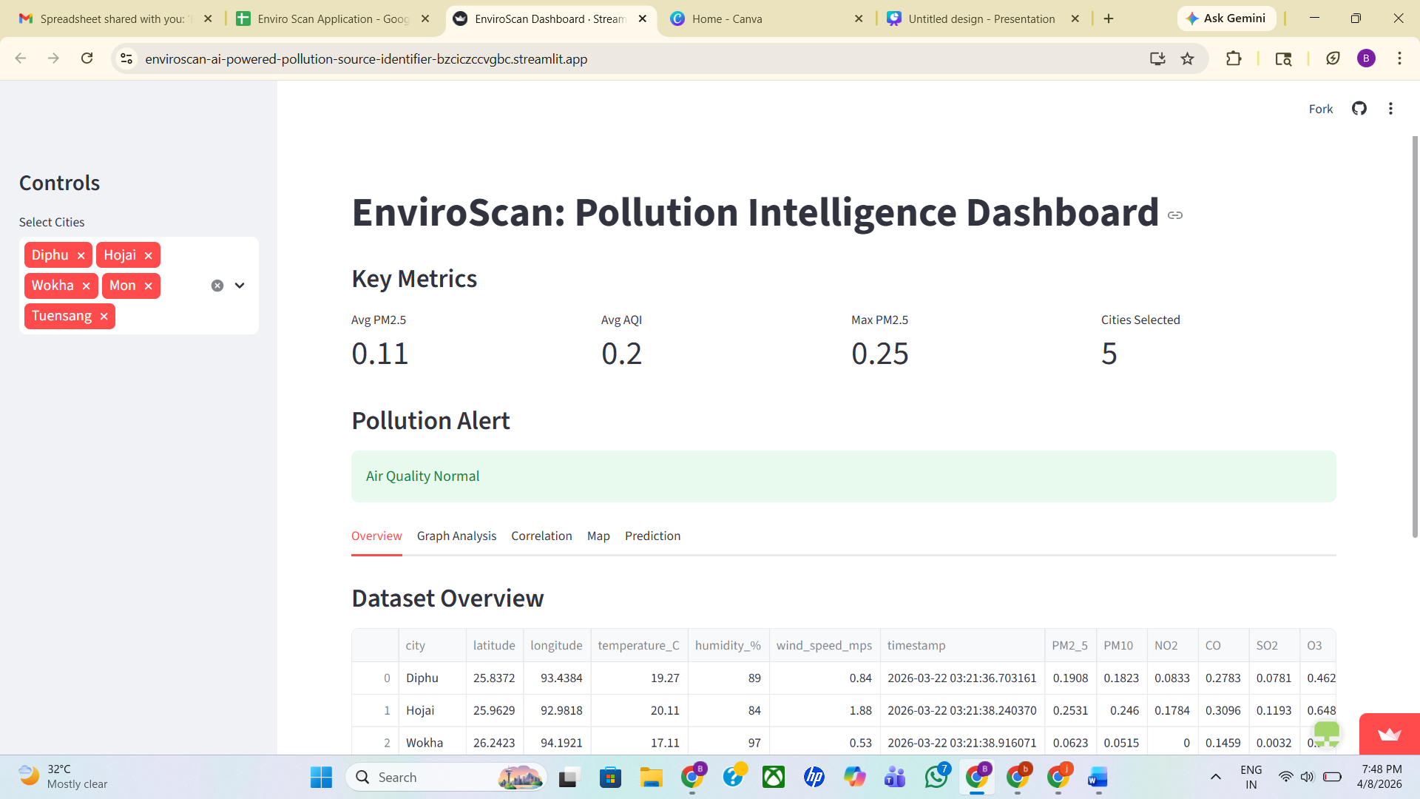
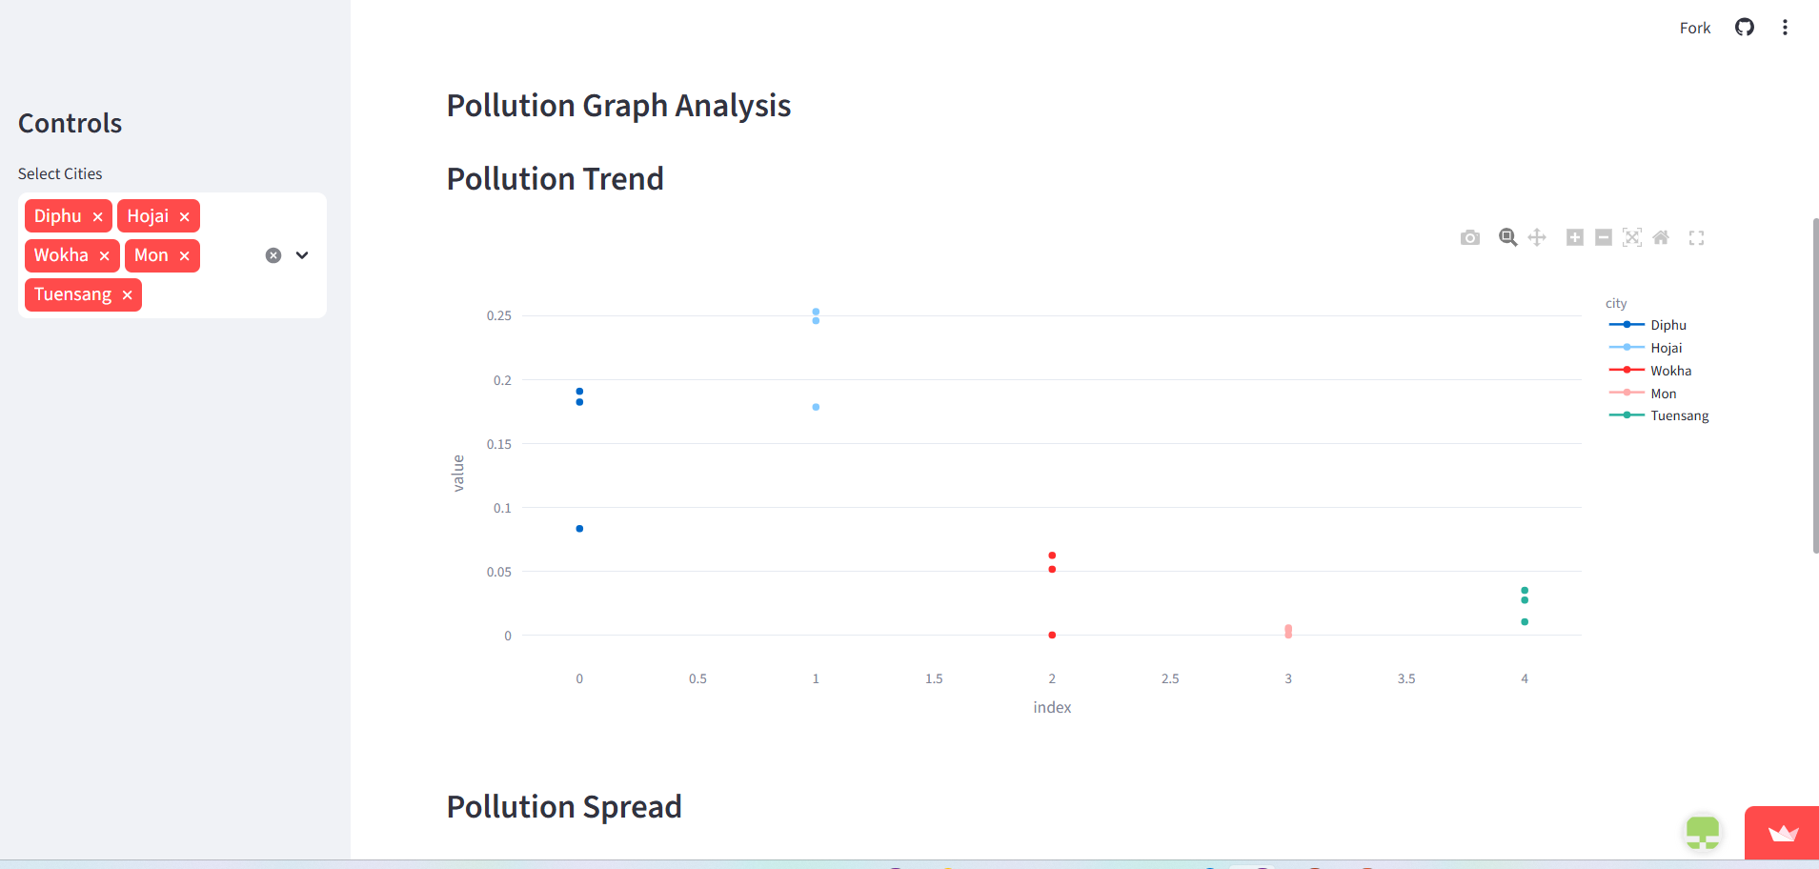

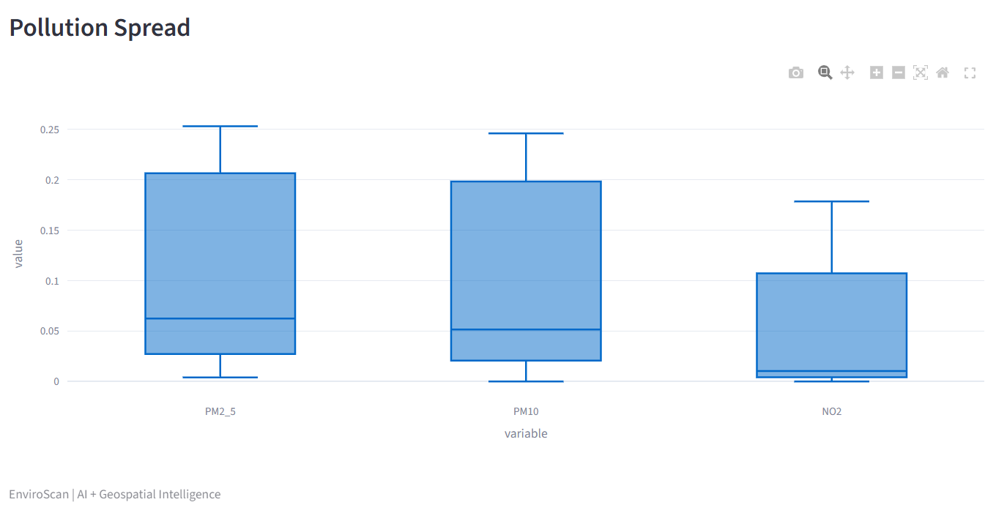

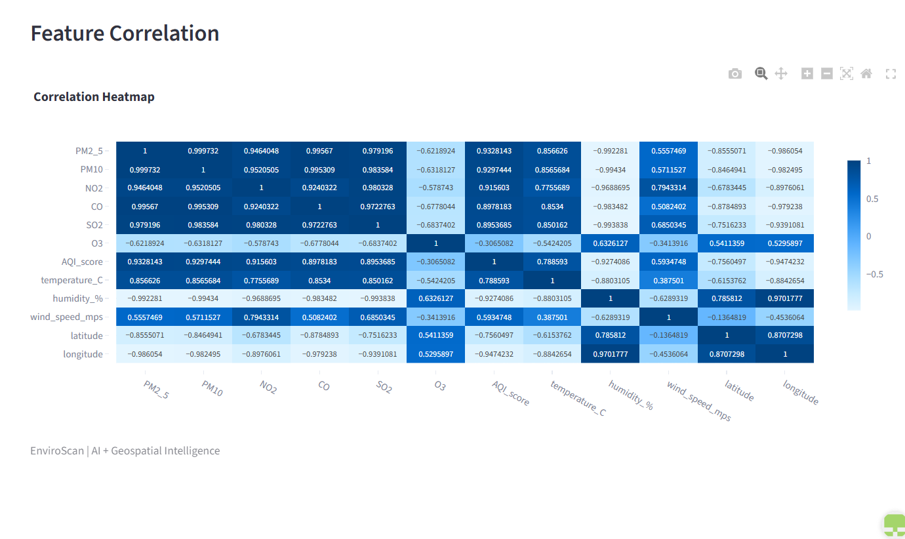
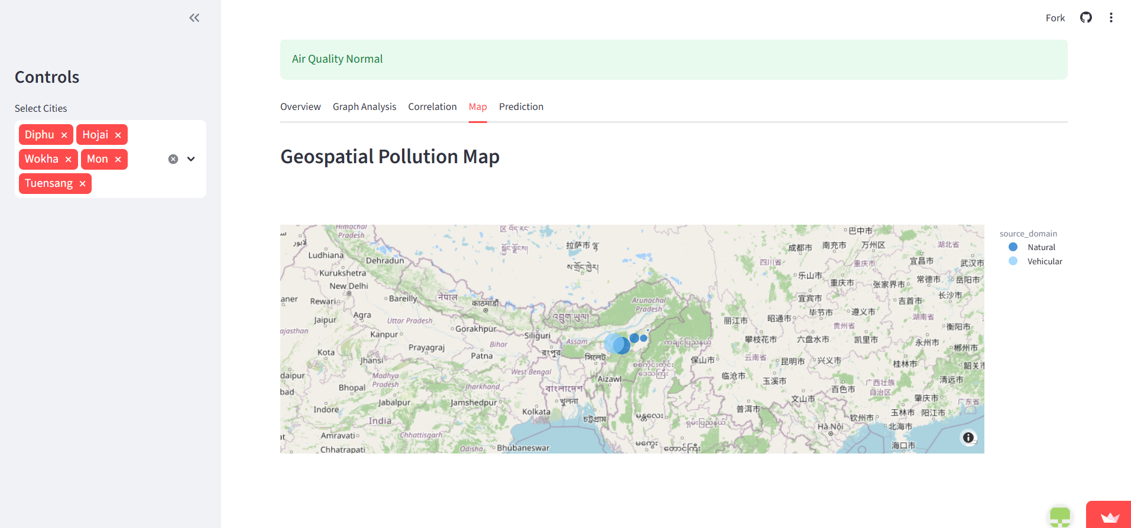

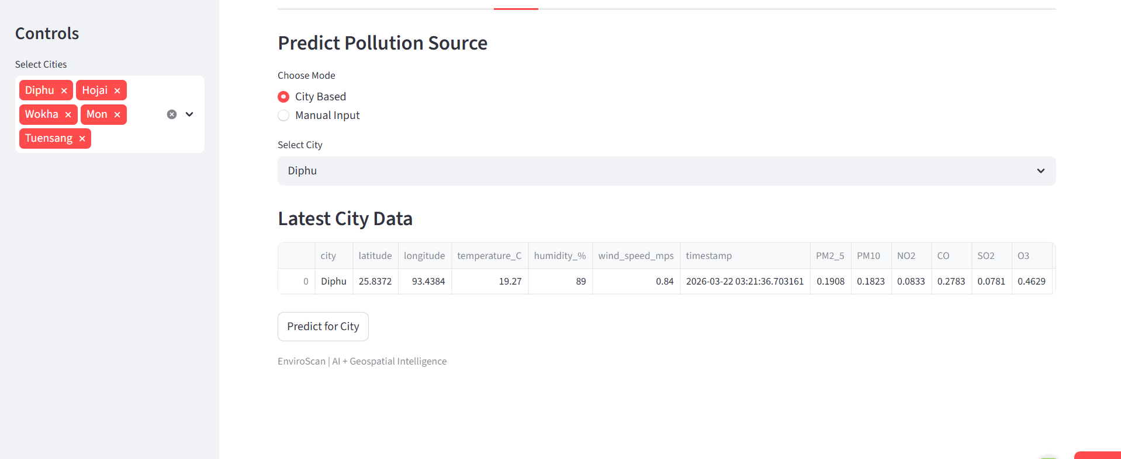

- Solution
EnviroScan provides a complete solution for pollution analysis by integrating data processing, machine learning, and visualization into a single platform.
The system:
- Identifies pollution sources using intelligent classification
- Provides visual insights through maps and charts
- Allows users to analyze trends and patterns
- Supports decision-making by highlighting critical areas
This approach makes pollution data more actionable and useful for both individuals and authorities.

- Conclusion
EnviroScan highlights the importance of going beyond basic pollution monitoring. By identifying the source of pollution and presenting it through an interactive system, it enables better understanding and decision-making.
The project shows how modern technologies like machine learning and geospatial analysis can be applied to solve real-world environmental problems. With further improvements and real-time data integration, the system can be expanded into a full-scale solution for pollution management and control.

Submitted By
Paturi Bhavana

